T.A: Abdelrhman Solyman
Name: Mohamed Elsayed Mohamed Khayami
Reg#: 221010750

12th Assignment

Task1:
c. (inserting integers into the files should be done concurrently)(attach Screenshot).
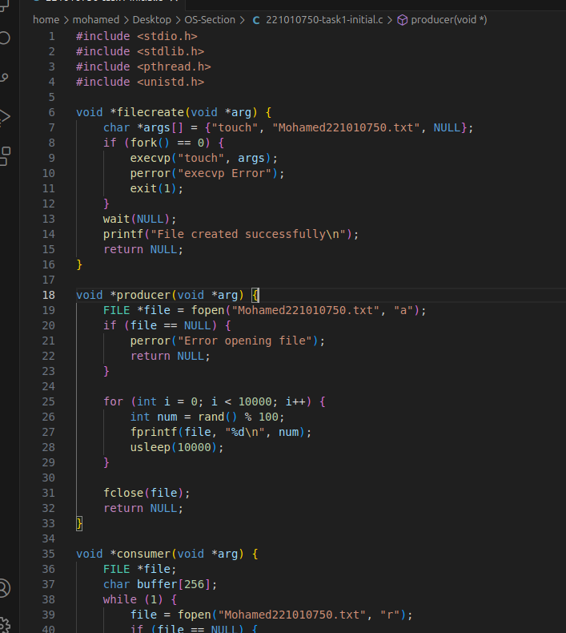

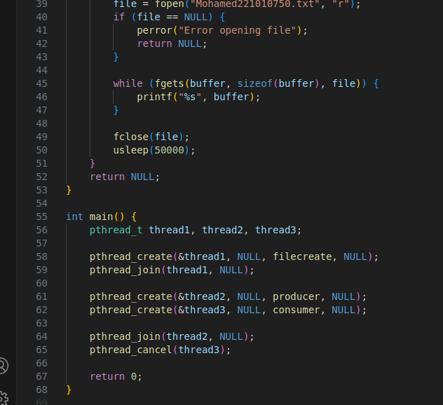

d. 3rd Thread will act as consumer and read the files concurrently, print the output to console (attach Screenshot).
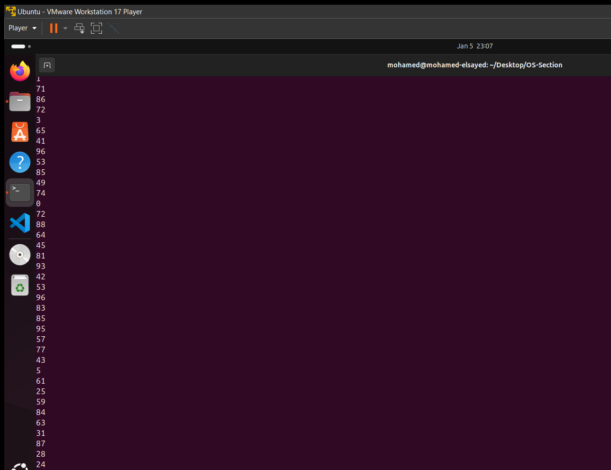

f. Identify the critical sections in the code (attach Screenshot).
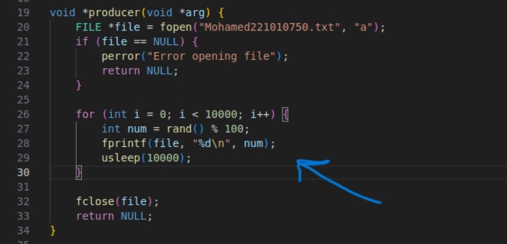
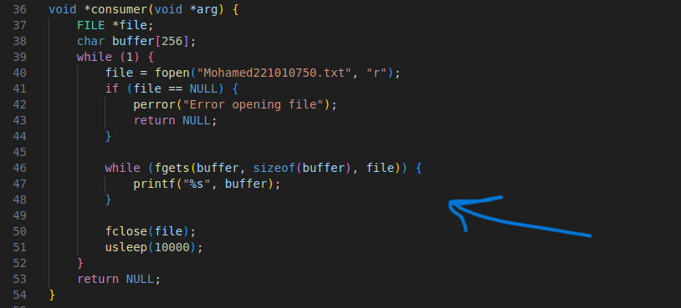

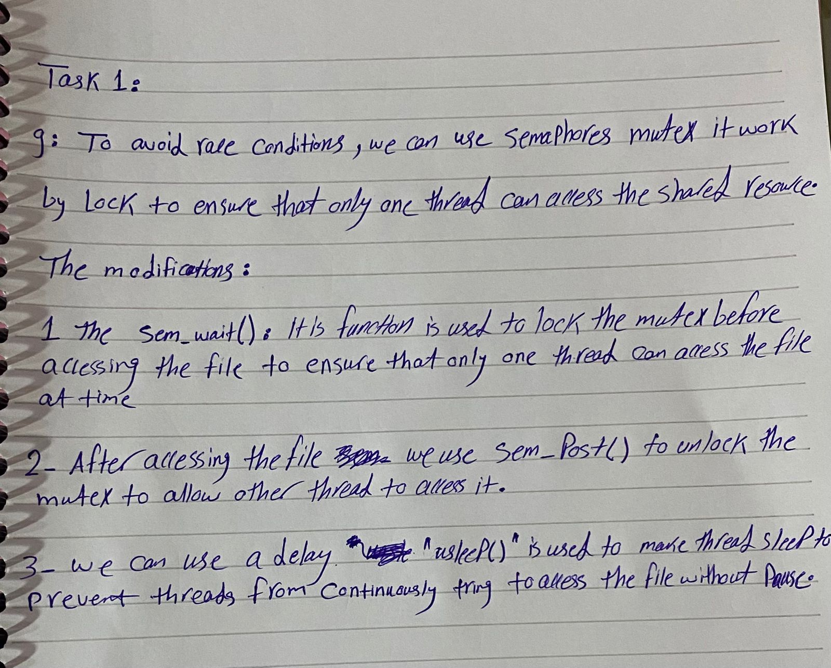
g. Suggest your modifications to avoid the problems you may encounter “Racecondition” using semaphores to apply mutex, justify your answers in a written paper(attach scan copy of the paper).

Task 2 [Bonus]:
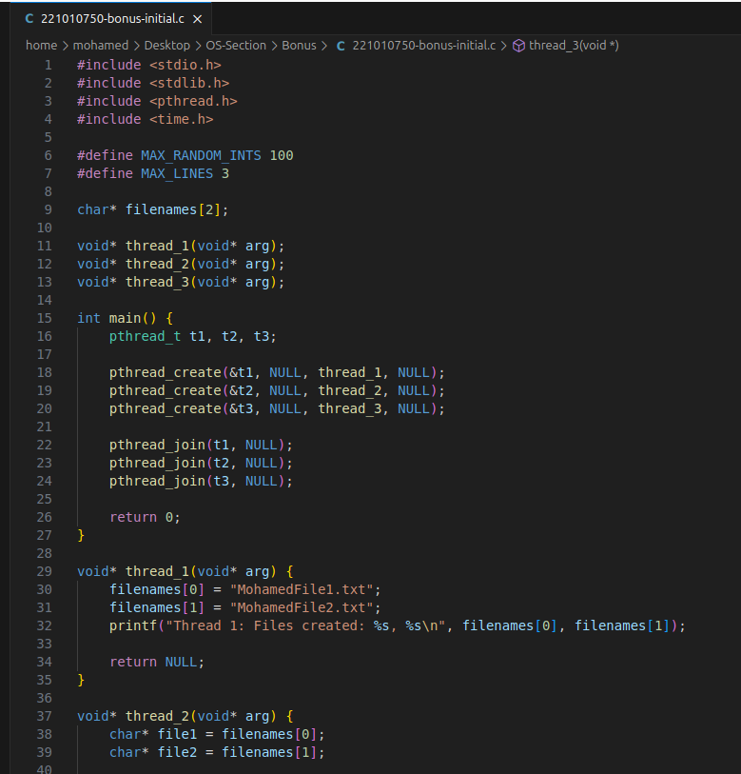
c. (inserting integers into the files should be done concurrently with the consumer) (attach Screenshot).
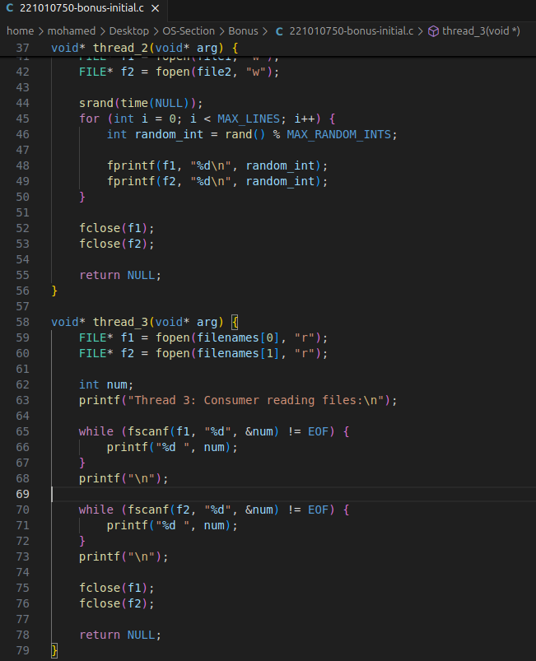

d. 3rd Thread will act as consumer and read the files concurrently with the producer, print the output to console (attach Screenshot).
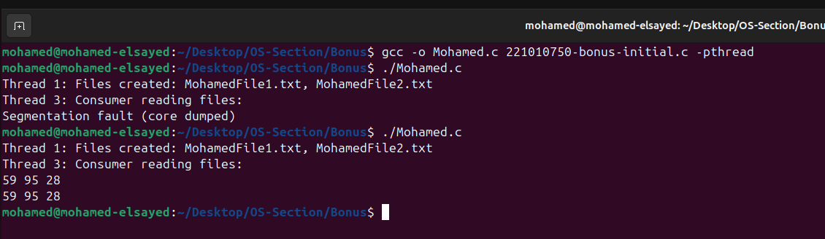
f. Identify the critical sections in the code (attach Screenshot).\
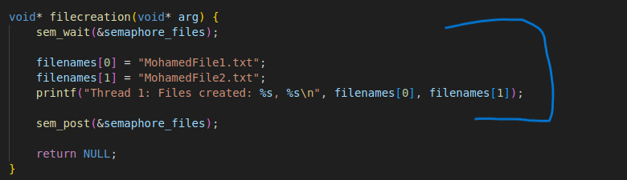

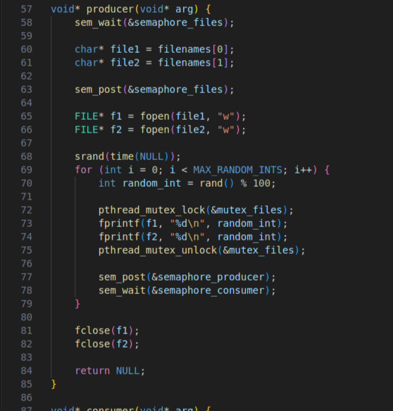

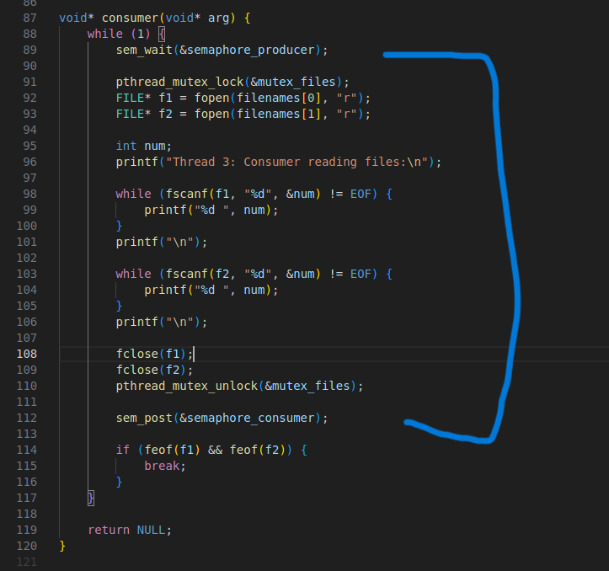

g. Suggest your modifications to avoid the problems you may encounter “Race condition” using semaphores to apply mutex among all threads, also state how can you check if all data produced by producer is read by consumer and no data was lost or overwritten, justify your answers in a written paper (attach scan of the paper).
